Resume

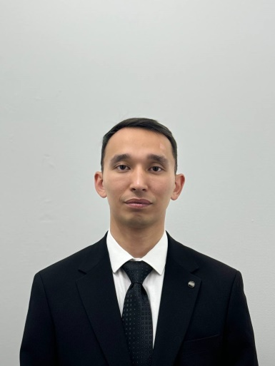 | Full Name  (by identity card) | Sharipov Murat Khalmatovich
 | Date of Birth | 21.05.1998 г.
 | Gender (male / female) | Male
 | Nationality | Kazakh
 | Citizenship | The Republic of Kazakhstan
 | Mobile phone,  Email | 8 707 852 33 62,  mura666232@mail.ru
Place of work: | NAO "Kazakh National Agrarian Research University"
Position: | Part-time Assistant of the Department of Forest Resources, Game Management, Fisheries
Academic degree, title: | -
Education: | Higher, Kazakh Agrotechnical University, specialty "Forest Resources and Forestry", 2020
Work experience: | 2020 to the present. – RSE "Kazakh Forest Management Enterprise" - Electronics Engineer  From 2024 to the present, she has been a part-time assistant at the Department of Forest Resources, Game Management, Fisheries of KazNARU.
International internships: | -
Activities in the service sector (within and outside the institution): | -
Scientific activity Head and/ or performer of research in the Republic of Kazakhstan | -
Training of highly qualified personnel: | -
Authorship or co-authorship in scientific or experimental design developments: | -
Educational and methodical publications: | -
Scientific publications: | Scientific articles 2  1. Интродуцент Павловния на юге Казахстана, ISSN 2308-4804. Science and world. №9 (109) 2022, 46-48. Волгоград  2. Планирование информационных систем на основе географических карт и экологических кадастровых данных. Наука молодых 2022. С 161-169. Сборник статей III Международного научно-исследовательского конкурса, состоявшегося 19 декабря 2022 г. в г. Петрозаводске часть 1
Rewards: | -
Knowledge of languages: | Kazakh – native, Russian – fluent

